Independent Reading-1st half of book

Independent Reading

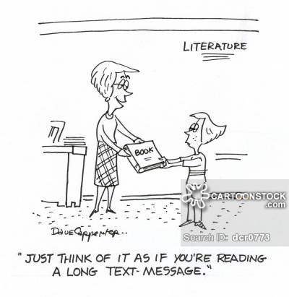

**TASK**

Divide your book into two equal sections. As you read, you’ll be marking the text with post its to note your observations about writer’s craft as well as your own thinking and analysis. You need *at least 15 post* its in the first half of the book.

**RESPONSE IDEAS**

You are to identify the device/technique/point of interest AND note how/why it matters in that part of the story or to the story as a whole. Bullet points and/or fragments are permissible. While these are ideas for what you can point out, note that the goal is for to have a VARIETY of types of post its and responses.

|  |  |
| --- | --- |
| **FICTION IDEAS** | **NONFICTION IDEAS** |
| Lit elements   * Characterization * Conflict * Symbol * Mood * Setting * Point of View * Imagery * Simile * Metaphor * Foreshadow * Flashback * Allusion * Hyperbole * irony   Style/story-telling technique   * Dialogue * Punctuation * Chapter titles * Significance of character names * Word choice (slang? Difficult vocab?)   Other ideas:   * Make a prediction (and why you think it) * Ask a question * Define vocab word you don’t know * Make a connection to another book, movie, show, etc. | Lit elements   * Conflict * Mood * Point of View * Imagery * Simile * Metaphor * Hyperbole * Foreshadow   Elements of SOAPSTone   * Speaker (who tells the story? What kind of person is he/she? Is he/she reliable?) * Occasion (why is the book being written) * Audience (to whom is the book directed? What kind of people would want to/should read it?) * Purpose (why is the author writing the book? “to+verb…) * Subject (main idea/topic/issue) * Tone (author’s opinion/attitude toward a subject matter)   Style/story-telling technique   * Text features (maps, charts, pictures, quotes from other authors at the start of a chapter) * Organization (compare/contrast, cause/effect, “how to”) * Connection to another book, movie, show… * Word choice (slang? Difficult vocab?) * Punctuation * Dialogue * Chapter titles |

**FLIP OVER🡪**

**SAMPLE POST IT in BOOK**

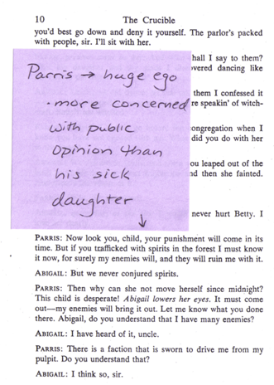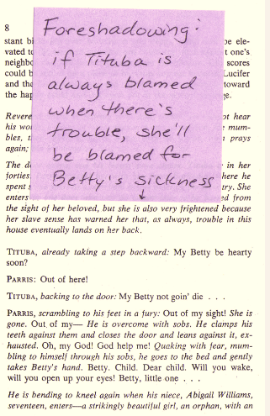

**FIVE TYPED BEST POST IT NOTES**

In addition to your post it notes, you will also pick your **5 best observations/analyses to type up and submit** for my closer review. Label the context and post it/analysis, and be sure to write in *FULL SENTENCES*.

**FORMAT:**

* Context: Explain what’s happening (in only 1 or 2 sentences) at the point in the book that you placed a post it note.
* Post It/Analysis: Tell me what you observed/noted in the book and how/why it matters to that section of the story or the book as a whole. What is significant about it? Include brief evidence and cite it (3-4 sentences).

**MODEL:**

* Context: Before the play starts, Abby and Betty were caught dancing in the woods, and now Betty won’t wake.
* Post It/Analysis: Stage directions reveal that whatever is wrong with Betty will probably be blamed on Tituba because “trouble in this house eventually lands on her back” (Miller 8). As a slave, Tituba is a scapegoat that people can easily oppress since she has low status. The line foreshadows that since no one ever comes to her rescue, she will be an easy target for this unusual situation.